Illinois Harvest of the Month 101

Program Overview
Illinois Harvest of the Month celebrates a different in-season, locally grown food item every month. Registered school districts and early care sites receive a seasonal calendar of suggestions for what to feature, then choose what works best for their meal program.
It’s a free and flexible way to buy and serve more local food while teaching students about healthy eating, nutrition, and agriculture!

How do I register?
Representatives from school districts and early care sites can register for the program by visiting www.harvestillinois.org. There is no cost to join. Annual registration opens in the spring and closes by November 1st.

Program Requirements:
- Participate in at least one check-in phone call with the Illinois Farm to School Network’s Program Manager
- Fill out two surveys over the year to share updates and feedback
- Display the Illinois Harvest of the Month signs and other materials in participating cafeterias.

Register now –
it’s free! www.harvestillinois.org

Harvest of the Month Resources:
- Calendar with seasonal food options to choose from each month
- Harvest of the Month icons to use on menus, websites, social media, and more
- Fun & nutrition facts for over 20 foods
- 100+ recipes for foodservice, summer feeding programs, and early care meals
- Materials to share with families & local grocery stores or farmers markets
- Monthly emails with celebration tips
- One-on-one technical assistance

Where do I find local food?
Never fear! The Illinois Farm to School Network is partnering with FarmLogix to ensure availability of local items through broadline and produce distributors. We also encourage sites to source from their own school or program gardens, or consider building direct relationships with local farmers.
Whichever path works for your program, all registrants are provided free resources and technical assistance to help make it easier.

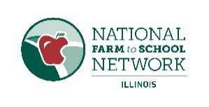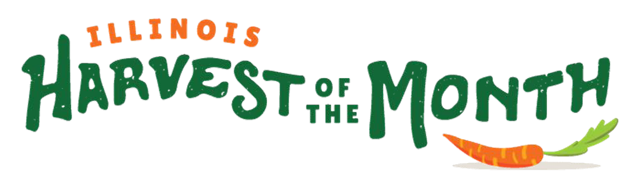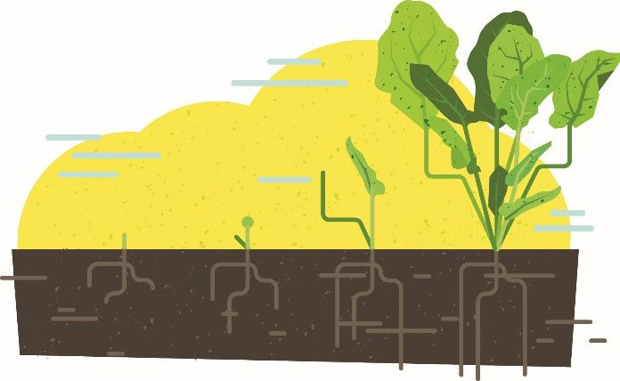

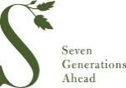

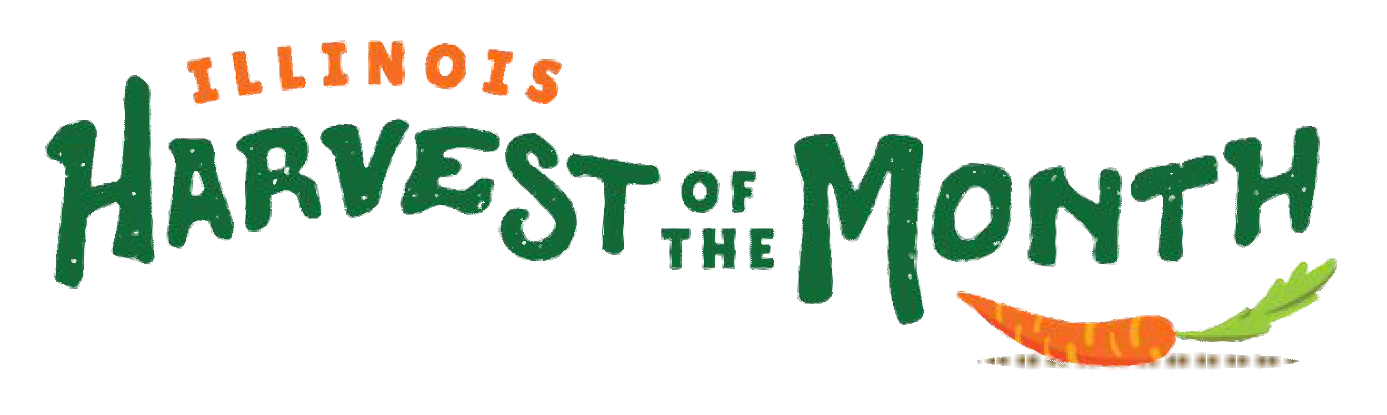
2018-2019 Seasonal Calendar

Register now! www.harvestillinois.org

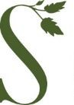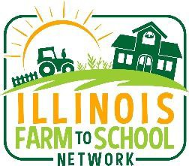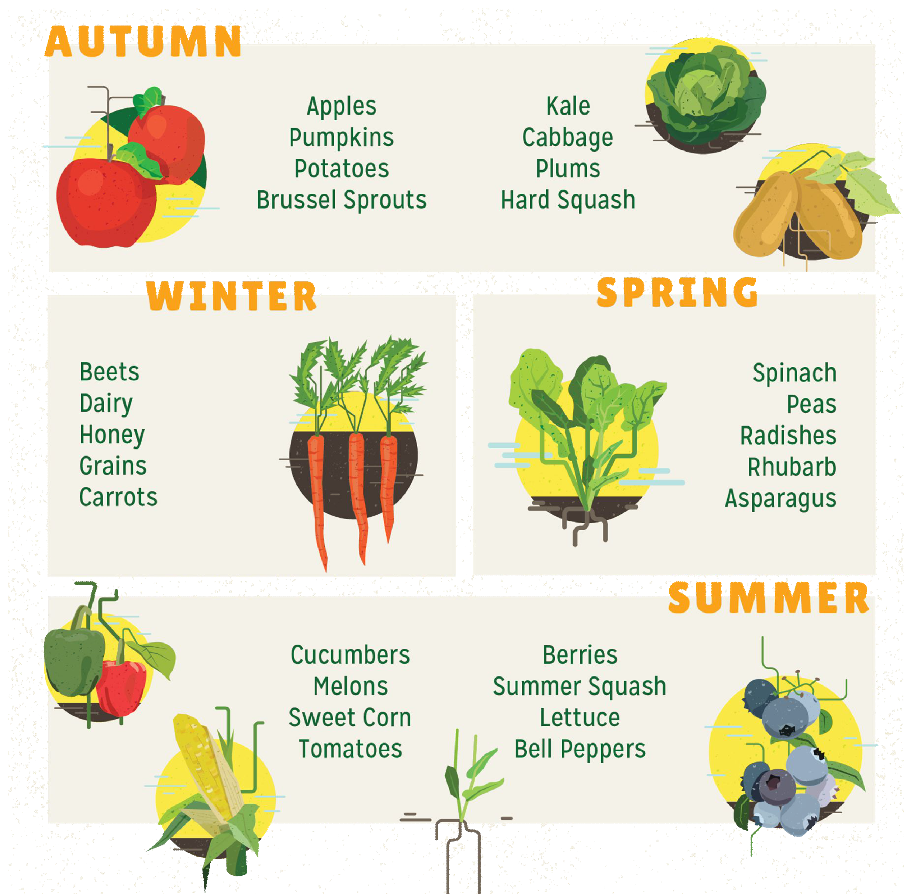Illinois Farm to School Network is a program of Seven Generations Ahead and a Core Partner of the National Farm to School Network.
Illinois Farm to School Network
Office: 708.660.9099
www.illinoisfarmtoschool.org Find us on

